**Shaw, George Bernard (1856-1950)**

Bernard Shaw was an Irish playwright, music and drama critic, and political theorist who pioneered the play of ideas as a dramatic genre, was instrumental to the formation of the Labour Party in England, and is the only person to have won both the Nobel Prize for Literature (1925) and an Academy Award (1938, Best Adapted Screenplay, *Pygmalion*). The intellectual and social seriousness of his ideas, his effusive, literary dialogue, and his invention of new genres like the discussion play were pivotal contributions to the modernization of drama.

Born into a Protestant family in Dublin, Shaw moved to London in 1876 and began ghostwriting a music column for *The Hornet* while also pursuing an unpromising career as a novelist and becoming involved with the Fabian Society, a British socialist organization that promoted a gradualist rather than a revolutionary approach to social reform. In *The Quintessence of Ibsenism*, initially delivered to the Fabians as a lecture in 1891, Shaw articulated his nascent dramaturgical principles. He argued that Ibsen’s most important contribution to the development of modern drama was replacing the violent catastrophes of melodrama with discussion scenes in which characters sat down and talked about intractable social problems. Shaw’s views about modern drama were put into practice in his first three plays: *Widowers’ Houses* (1892), about slum landlordism, *The Philanderer* (1893), about divorce, and *Mrs. Warren’s Profession* (1893), about prostitution. In response to censorship and outrage at his direct attacks on social evils in these ‘plays unpleasant,’ as he referred to them, Shaw produced three comedies that castigated romantic ideals by provoking laughter: *Arms and the Man* (1894), which was his first stage success, *Candida* (1894), and *The Man of Destiny* (1897). *Plays Unpleasant* and *Plays Pleasant* were published in 1898 with lengthy stage directions and prefaces, both to bypass the Lord Chamberlain’s office, which censored stage productions but not printed texts, and to position Shaw’s drama as the intellectual equal of the novel.

Many of Shaw’s plays were first produced between 1904 and 1907 at the Royal Court, a repertory theatre founded by Harley Granville-Barker and J. E. Vedrenne. Shaw wrote *Man and Superman* between 1901 and 1903 to dramatize his philosophy of Creative Evolution, in which men and women participate, sometimes unwittingly, in the breeding of politically and ethically superior beings. In the 1905 Court production, Granville-Barker played the philosopher-hero John Tanner—made up to look like Shaw.

Other key works of the early twentieth century included Shaw’s only full-length play set in Ireland, *John Bull’s Other Island* (1904), in which he tackled the exploitation of Irish landowners by British landlords, and *Major Barbara* (1905), in which he proposed that socialism might only be achieved through a temporary partnership with industrial capitalism. Shaw continued to experiment with the dramatic potential of discussion in what he called his “disquisitory plays,” *Getting Married* (1908) and *Misalliance* (1909): both are sustained debates, without intermission, on the subject of divorce laws and the relationship between parents and children, respectively. His most durable success, *Pygmalion* (1913), premiered in Vienna and then in New York and London, the latter production directed by Shaw himself, and inspired the 1956 musical *My Fair Lady* by Alan Jay Lerner and Frederick Loewe. A satire on social class, *Pygmalion* centers on the bet that Henry Higgins, a professor of phonetics modeled on Shaw’s friend Henry Sweet, can transform a Cockney flower girl, Eliza Doolittle, into a duchess by changing her pronunciation. Despite the desire of audiences and actors for a love plot between Higgins and Liza, Shaw denied a romantic conclusion to the play and wrote a prose sequel in 1916 to foreclose a future marriage.

In response to the outbreak of World War I, Shaw published an incendiary pamphlet, *Common Sense About the War* (1914), in which he accused the British of being as culpable as the Germans in causing the war by sowing discontent through the unjust distribution of wealth. Newspapers encouraged their readers to boycott his plays and charged him with treason. Shaw suppressed *Heartbreak House* (1919), his play on similar themes, until a peace was brokered. In this symbolic drama, he assembled representatives of pre-war culture and power in a house shaped like a sailing vessel to suggest a recklessly steered ship of state. According to Shaw’s diagnosis, the unfulfilling pursuit of love, pleasure, and money by the ruling class led to a lust for death.

In 1921, Shaw completed his master statement on Creative Evolution, a five-play cycle called *Back to Methuselah* that tracks human progress through willed mutation from the Garden of Eden to a utopian community in 31,920 A.D. In *Saint Joan* (1923), a chronicle play written shortly after the canonization of Joan of Arc, he expressed a more pessimistic view of human history. Shaw’s Joan promotes nationalism against feudalism and advocates the return of religious consciousness to a skeptical world. Shaw binds the fifteenth and twentieth centuries in the play’s epilogue, a discussion between Joan, the men who executed her for heresy, and an emissary from the present that concludes that the world is still not ready to receive its saints. In his later years, Shaw became publicly fascinated with Benito Mussolini, Joseph Stalin, and Adolph Hitler, figures whose charisma and world-changing potential he explored in his drama, such as *Geneva* (1938),

Although his irregular support of totalitarianism at the end of his life tarnished his reputation somewhat, playwrights as diverse as Bertolt Brecht, Tom Stoppard, and Tony Kushner have cited Shaw as a major influence. His works continue to be performed around the world, as well as at the annual Shaw Festival in Niagara-on-the-Lake, Ontario, Canada.

**List of Works:**

Shaw, Bernard. (1965) *Collected Letters*, ed. Dan H. Laurence, 4 vols., London: Reinhardt.

-----. (1970-4) *Collected plays: with their prefaces*, 7 vols., London: The Bodley Head.

-----. (1993) *The Drama Observed*, ed. Bernard F. Dukore, 4 vols., University Park: Pennsylvania State University Press.

-----. (2006) *What Shaw Really Wrote About the War*, ed. J. L. Wisenthal and Daniel O’Leary, Gainesville: University Press of Florida.

**References and further reading**:

Dietrich, R. F. (1996) *Bernard Shaw’s Novels: Portraits of the Artist as Man and Superman*, Gainesville: University Press of Florida.

Griffith, Gareth. (1993) *Socialism and Superior Brains: The Political Thought of Bernard Shaw*, London, New York: Routledge.

Holroyd, Michael. (1997) *Bernard Shaw*, New York: Random House.

Meisel, Martin. (1963) *Shaw and the Nineteenth-Century Theater*, Princeton: Princeton University Press.

Morgan, Margery. (1972) *The Shavian playground: an exploration of the art of George Bernard Shaw*, London: Methuen.

**Lawrence Switzky, University of Toronto**

**Recommended Illustrations**

[Note: Please use all illustrations if possible, but if not, please prioritize the three production photographs above the portrait and video footage of Shaw.]

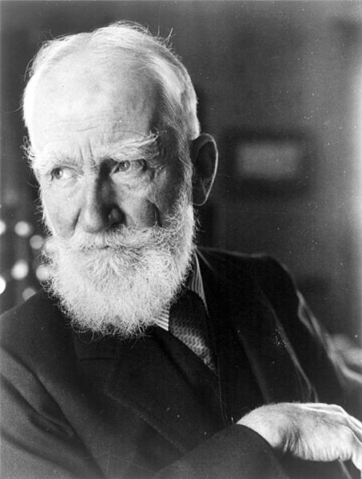

**Bernard Shaw (1934)**

[Available at: <http://pt.wikipedia.org/wiki/Ficheiro:George_Bernard_Shaw_1934-12-06.jpg>]

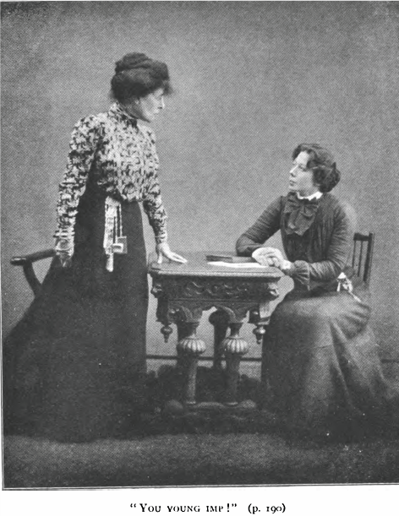

**Fanny Brough as Mrs. Warren and Madge McIntosh as Vivie Warren during the Act II "discussion scene" in the 1902 Stage Society production of *Mrs. Warren's Profession* at the New Lyric Club in London.**

[This image is available on the internet at <http://gowns.tumblr.com/post/394018023/oh-hell-yes-in-the-middle-of-the-book-is-a>, but it comes originally from the standalone Grant Richards "Stage Society" edition of *Mrs. Warren’s Profession* printed in 1902. It is also reprinted on p. 61 of Leonard Conolly's edition of *Mrs. Warren's Profession* from Broadview (2005), where it is sourced as follows: "Courtesy Dan H. Laurence Collection, L. W. Conolly Theatre Archives, University of Guelph."]

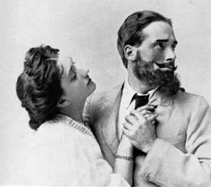

**Lillah McCarthy (Ann Whitefield) and Harley Granville Barker (John Tanner) in the Court Theatre production of *Man and Superman* (1905)**

[Available at:<http://media-cache-ak0.pinimg.com/236x/a7/27/0c/a7270cc8bdbb5b325cdf5ce435b86081.jpg>]

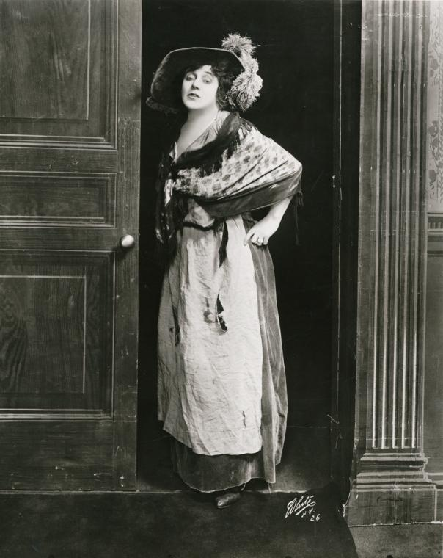

**Mrs. Patrick Campbell as Eliza Doolittle in *Pygmalion*.**

[Source: Billy Rose, Theatre Collection, New York Public Library, Digital Image Gallery, Image ID: psnypl_the_4390. Available at: <http://digitalgallery.nypl.org/nypldigital/id?psnypl_the_4390> ]

**Shaw’s “First Visit to America” (Movietone, 1928)**

<https://www.youtube.com/watch?v=40VegR6uaTI>